

Cal Poly

California Polytechnic State University, San Luis Obispo, CA 93407

Date: May 15, 2009
To: Sherrie Amido
Fr: Cal Poly PASS Task Force
Re: PASS Website Analysis



In Brief
- PASS makes the task of planning a
schedule for students much more
tedious and difficult than it needs to
be

- Comparing schedules with the
current PASS can be as difficult as
having to write each schedule
down. The updated version would
allow side-by-side schedule viewing.

- In the updated version of PASS,
classes would no longer be listed as
“open” near the end of enrollment
when they are actually “closed.”
This would be achieved by
combining PASS and CPReg.

- Combining PASS and CPReg would
also allow for direct enrollment
without having to copy information
from one site to the next.

- A flow chart will be provided for
each student based on major, with
the additional option to auto-fill
a schedule with required classes
from the flow chart.


Students Using the PASS Website

Ask yourself: PASS or fail? Based on the complaints of most students at Cal Poly, it seems the consensus is “fail.” Once every ten to twelve weeks, Cal Poly students are required to plan a new schedule for the upcoming quarter through PASS. Many students have had problems with it, whether it was trying to switch between two different schedules to compare them, having to transfer information from PASS to CPREG to register, or timing out just before you save your schedule. We believe that PASS is a very useful tool but there are still many flaws in the website. This report will explore and examine these flaws, and also propose ways to fix them in order to make PASS a more accessible, comprehensive, and easy to use website. By doing so students will be able to complete their schedules more quickly, and in some cases our proposals may even help students to enroll in classes they would have otherwise missed.

Time Taken to Create a Schedule

It takes an average student 4 minutes to
complete one schedule to save on PASS,
and normally students will have 5-20
schedules to choose from. The number of
clicks required to get to a single schedule
with 4 classes, including marking your
availability, 32. With the proposed
improvements listed below, the number of
clicks is reduced to 16 and the time spent is
reduced to 2 minutes and 30 seconds per
schedule

Figure 1: The PASS website, selecting your availability
Source: http://pass.calpoly.edu/ 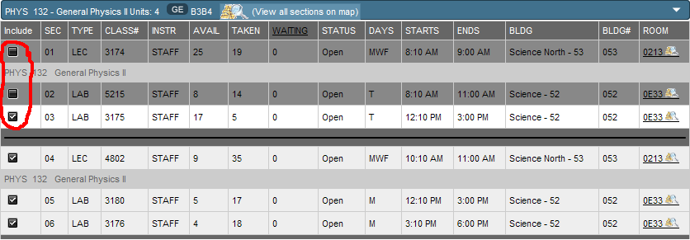

Availability

When you set your availability, PASS will uncheck and gray out the classes that don’t fit within your time frame (figure 1). However, if a lecture fits into your time frame but the associated lab does not (or vice versa), the system will not block out the lecture for you. PASS will not let you continue until you manually find and uncheck all of the associated courses. With better coding, the site could omit classes with lectures or labs that aren’t within your availability.

The site should give an option to uncheck all classes and uncheck all full classes.

Also, the availability section should be moved to the second page with the list of classes the student has selected. By doing this, the student doesn’t have to navigate away from the list of classes and lose their current selection if they wish to change their availability.

Schedule Format

The Select Schedule Section, page 3 on PASS (figure 2), should allow students to view their schedules in multiple ways beyond the current vertical list format. By being able to view multiple schedules at once, students could then compare a select group of schedules and save them individually if they choose to, saving much time and effort switching from one schedule to another.

Another viewing option could be a grid view, where the class times, currently on the right side of the page, would be arranged in a grid format as if they were files on a computer, with an option to “view as grid.” This would make it much easier to choose schedules based on the class time and, when coupled together with the ability to view multiple schedules at once, it would greatly facilitate the task of picking a schedule.

Right now you have to select each schedule individually to see what professors are teaching each course. With a new layout, students could first select

Figure 2: Grid Schedules
Source: http://pass.calpoly.edu
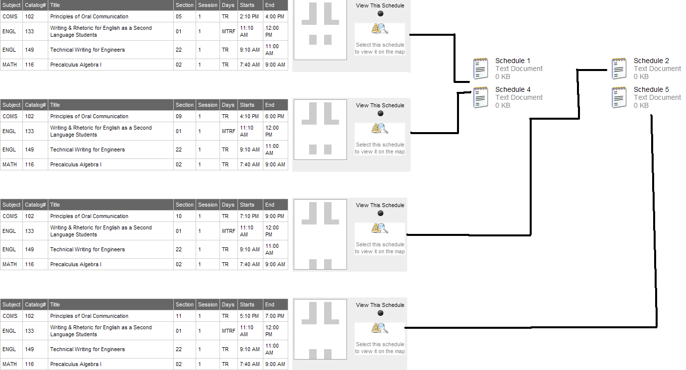

Schedule Format Continued

schedules by time in a grid view. This would allow students to plan schedules in a more informational view that is similar to the current page 3 on PASS, except with their teachers’ names added. This turns a multiple step process into just two easy selections.

Flowchart

Access to the various majors’ flow charts would be invaluable to students (figure 3). Also, PASS should incorporate an auto-fill feature based on the students major, that major's flow chart, the classes the student has already completed, and classes that are available. This would be a feature in step 1 of the current PASS, so students could auto-fill the recommended courses, then add or remove classes depending on what you want to take.
Web Design Flaws
Adding more colors to the design and background of PASS would improve its layout by making it more pleasing to the eye. The layout could also be improved by scaling the resolution based on the size of the screen. As is, PASS is difficult to view on a small screen. By scaling it based on resolution, this problem would be fixed.

The second page of PASS should contain a list of all possible classes, reducing the height of this page. Also, PASS would be easier to view if classes were color coded with closed classes highlighted in red and open classes in green. This would aid students in more quickly eliminating closed classes and picking those that are available.

Figure 3: Addition to PASS, Flowcharts by Major
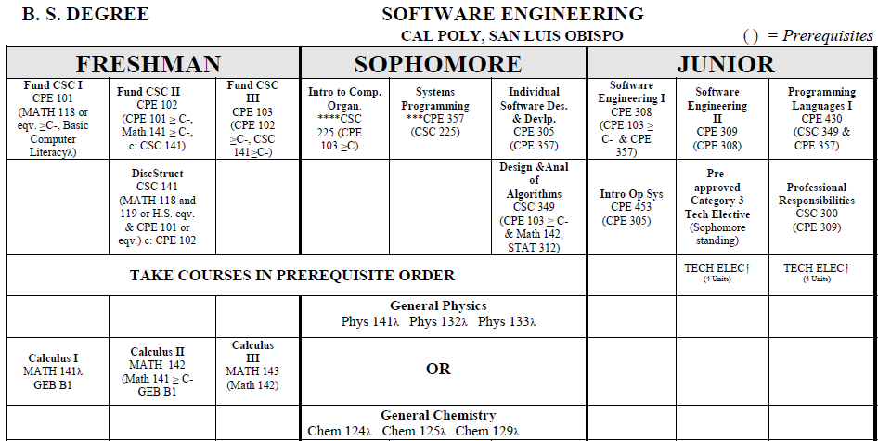
Source: http://eadvise.calpoly.edu/policy/forms/se_flow0709.pdf

Proposal Outcomes

We wish to create a more accessible PASS with easier side-by-side schedule viewing and a more up-to-date and accurate list of course instructors. Viewing different schedule options could be made easier through our “grid-viewing” option. Additionally, we strive to combine PASS and CPReg to allow fewer hassles caused by switching between the two, and thus increase efficiency. Our services will include access to the various majors’ flowcharts along with the option to auto-fill a schedule with required classes, user selected availability, and course offerings. This allows us to turn a once arduous process into a just few simple clicks.

Johnson-Sheehan, Richard. Technical Communication Today. 3rd ed. Longman, 2009, 365-3

